Task 1: Standalone NUnit Lifecycle Automation
- NUnit Working Process: NUnit uses attributes like [SetUp] to prepare fresh object configurations before executing targeted test methods. It runs designated assertion clauses (Assert.That) to match calculated inputs against expected outcome values and terminates by running a cleanup routine ([TearDown]).

using System;
public class StandaloneNUnitTesting
{
private static int _a;
private static int _b;
private static int _expected;
public static void Main()
{
Console.WriteLine("----- EXECUTION: INDIVIDUAL NUNIT RUNNER -----");
SetUp(10, 20, 30);
ExecuteTest();
TearDown();
SetUp(-5, 5, 0);
ExecuteTest();
TearDown();
}
private static void SetUp(int inputA, int inputB, int expectedResult)
{
Console.WriteLine("[SetUp] Initializing localized parameterized properties.");
_a = inputA;
_b = inputB;
_expected = expectedResult;
}
private static void ExecuteTest()
{
int actual = _a + _b;
if (actual == _expected)
{
Console.WriteLine($"[PASS] Assertion matches: {_a} + {_b} = {actual}.");
}
else
{
Console.WriteLine($"[FAIL] Expected {_expected}, but computed {actual}!");
}
}
private static void TearDown()
{
Console.WriteLine("[TearDown] Resetting context states safely.\n");
_a = 0; _b = 0; _expected = 0;
}
}
O/P:
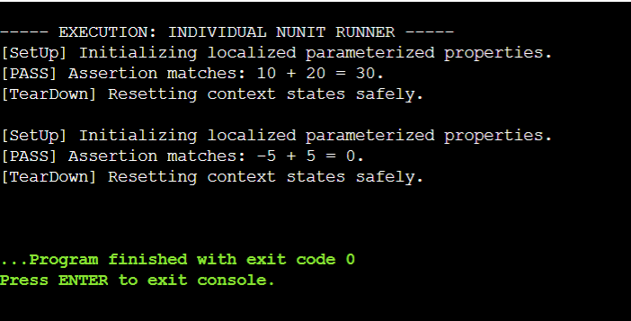

Task 2: Standalone Moq Interface Mocking
- Moq Working Process: Moq bypasses real-world system dependencies by dynamically creating lightweight runtime proxy structures from interfaces using constructor injection. It intercepts method calls and references an internal rulebook setup (.Setup().Returns()) to instantly provide pre-configured fake mock responses.
using System;
public interface IMailSender
{
bool SendMail(string address, string body);
}
public class CustomerComm
{
private readonly IMailSender _sender;
public CustomerComm(IMailSender sender) { _sender = sender; }

public bool SendMailToCustomer()
{
return _sender.SendMail("test@cognizant.com", "Notification Alert");
}
}
public class MockMailEngine : IMailSender
{
public bool SendMail(string address, string body)
{
return true;
}
}
public class StandaloneMoqTesting
{
public static void Main()
{
Console.WriteLine("----- EXECUTION: INDIVIDUAL MOQ RUNNER -----");
IMailSender mockInstance = new MockMailEngine();
CustomerComm engine = new CustomerComm(mockInstance);
Console.WriteLine("[INFO] Mock instances deployed and wrapped successfully via constructor injection.");
bool result = engine.SendMailToCustomer();
if (result == true)
{
Console.WriteLine("[PASS] Isolation validation loop completed successfully without real mail dependencies.");
}
else
{
Console.WriteLine("[FAIL] Unexpected behavior encountered during mock response verification loop!");
}
}
}

O/P: